Student Names

You can work in groups of up to three students. Write all names here. Submit only one report per group. Submit the report in PDF format.

ASSIGNMENT 2
FINANCIAL ECONOMETRICS

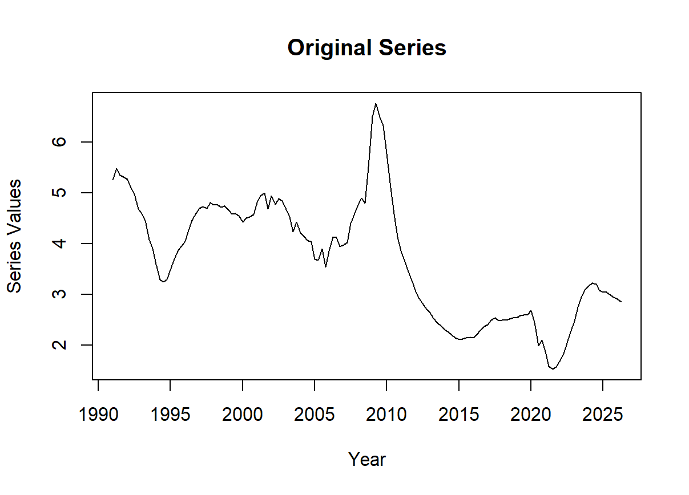
Paste the level series chart here

CREDIT CARD
DELINQUENCIES
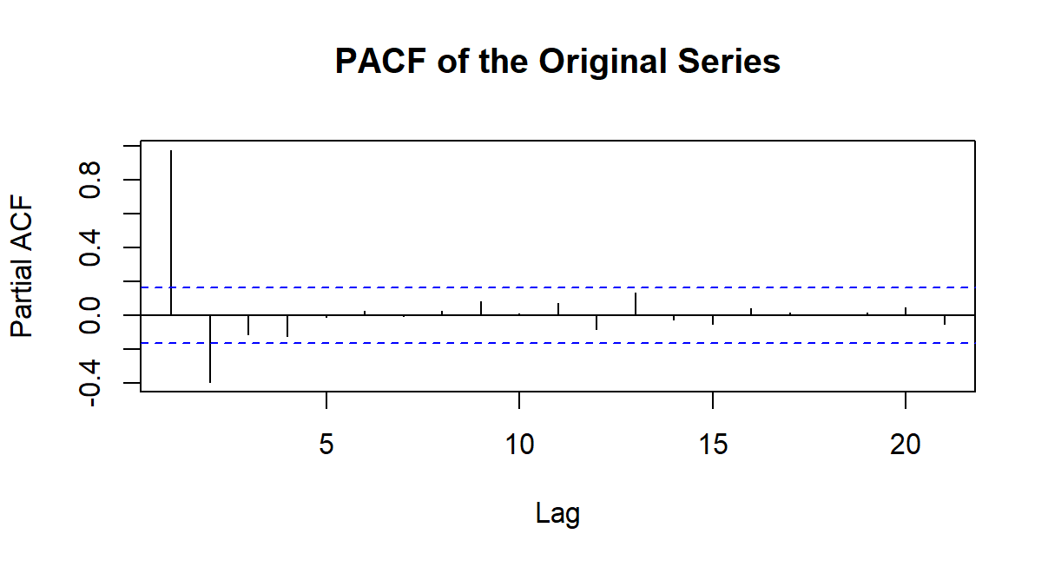
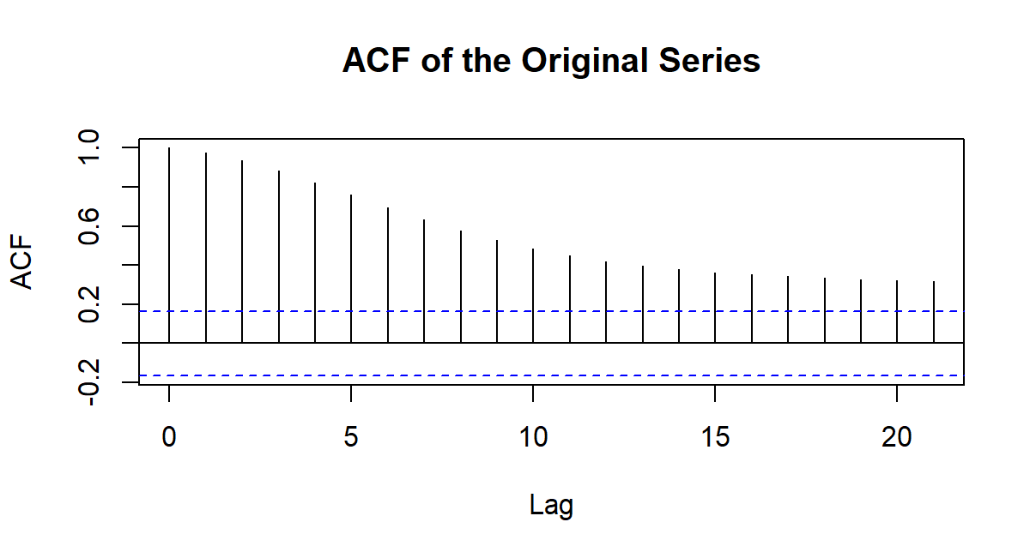
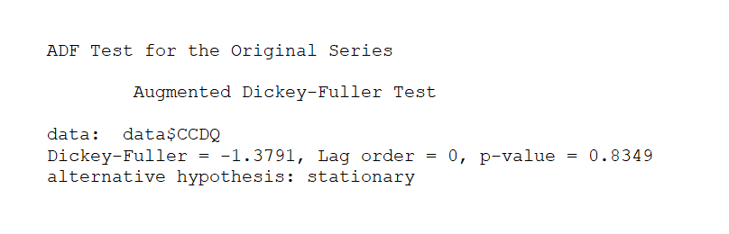
Paste the ADF test outputs for the level series here

In this and the next box paste the ACF and PACF for the level series

OTHER OBSERVATIONS

Use this box to describe important observations on the level series. Here, explain why you think these analyses are relevant, why do they matter? As you get the series ready for modeling and forecasting, use this box to point out any relevant observations from the outputs on this page.

Use this box to describe the ACF and PACF outputs for the credit card delinquencies level series. Paste the ACF and PACF outputs in the two bottom boxes to the right.

Use this text box to describe/discuss the time credit card delinquencies level series, what you observed, any thoughts on driving patterns, etc. Use the large box to the right to paste the level series chart.

LEVEL SERIES PLOT
ADF TEST FOR LEVEL SERIES

Use this box to describe the results of the ADF test for the credit card delinquencies level series. Paste the image of the ADF test result in the smaller box to the right.

ACF AND PACF

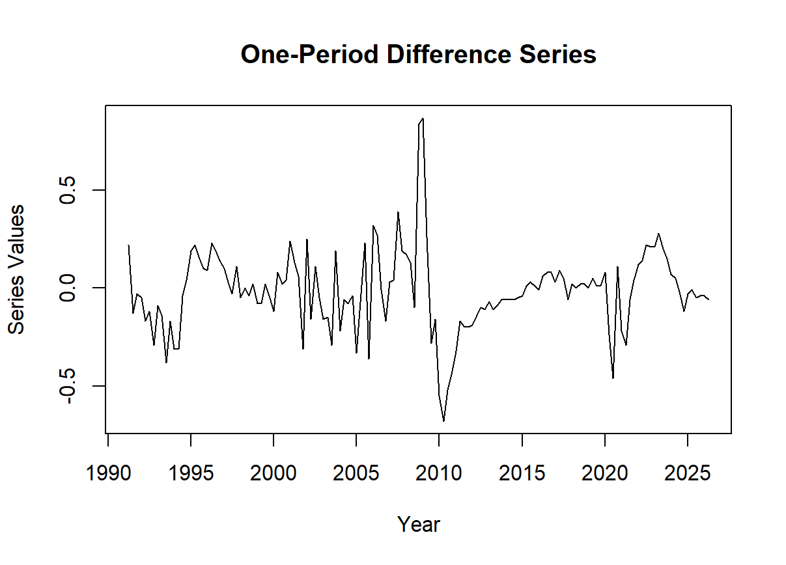
Paste the one-period difference series chart here

CREDIT CARD
DELINQUENCIES
ACF AND PACF FOR ONE_PERIOD DIFFERENCED SERIES

ADF TEST FOR ONE-PERIOD DIFFERENCED SERIES

Use this box to describe the results of the ADF test for the one-period difference credit card delinquencies series. Paste the image of the ADF test result in the smaller box to the right.

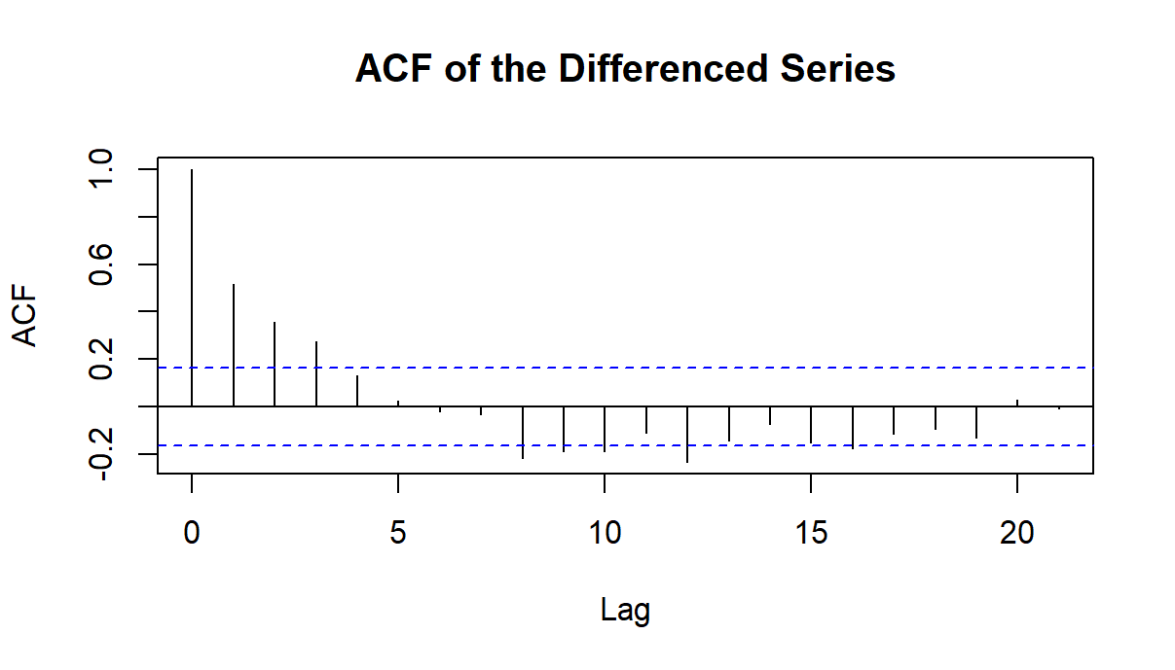
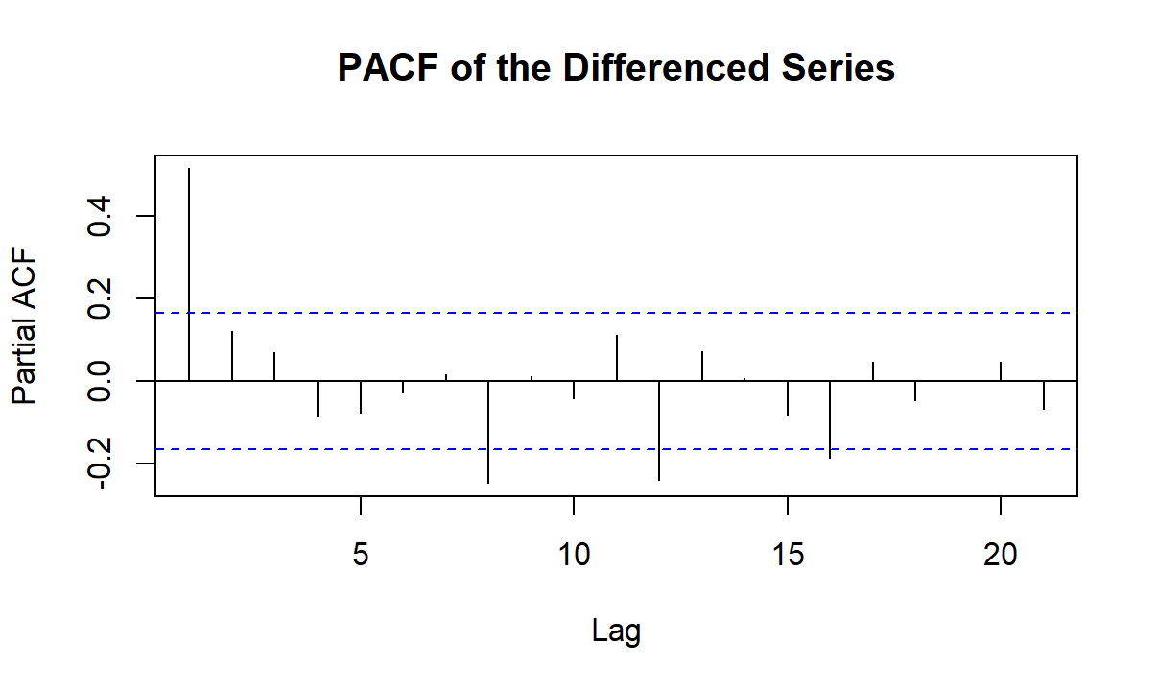
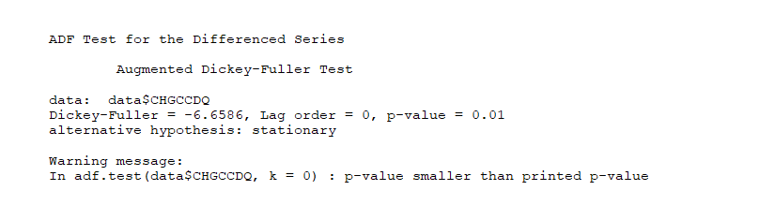
Use this box to describe the ACF and PACF outputs for the one-period difference credit card delinquencies series. Paste the ACF and PACF outputs in the two bottom boxes to the right.

ONE-PERIOD DIFFERENCE SERIES PLOT
Use this text box to describe/discuss the one-period difference credit card delinquencies series. Describe what you observe, thoughts on driving patterns, etc. Use the large box to the right to paste the level series chart.

In this and the next box paste the ACF and PACF for the one-period difference series

Paste the ADF test outputs for the one-period series here

Use this box to describe important observations as a result of applying the one-period difference. As you get the series ready for modeling and forecasting, use this box to point out any relevant observations from the outputs on this page.

OTHER OBSERVATIONS

CREDIT CARD DELINQUENCY SERIES, ARIMA
FORECAST OUTPUT
Use this text box to describe the ARIMA forecast results, how you did it and what you observe.

In the first box below, to the left, paste the actual vs. fitted chart from R. To the box to the right, paste an Excel chart with a portion of the actual series, together with the ARIMA forecast. Then, in the bottom left box, paste the residual diagnostics, and to the right, paste the Box-Ljung white noise test results. Follow the “How-To” video instructions.

CREDIT CARD DELINQUENCY SERIES,
ARIMA FORECAST

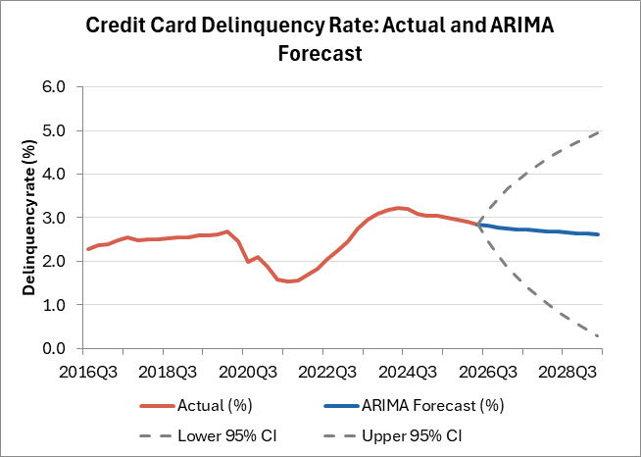
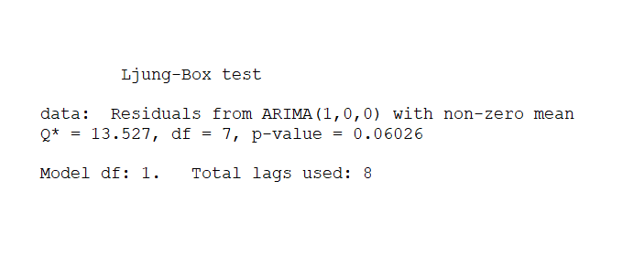
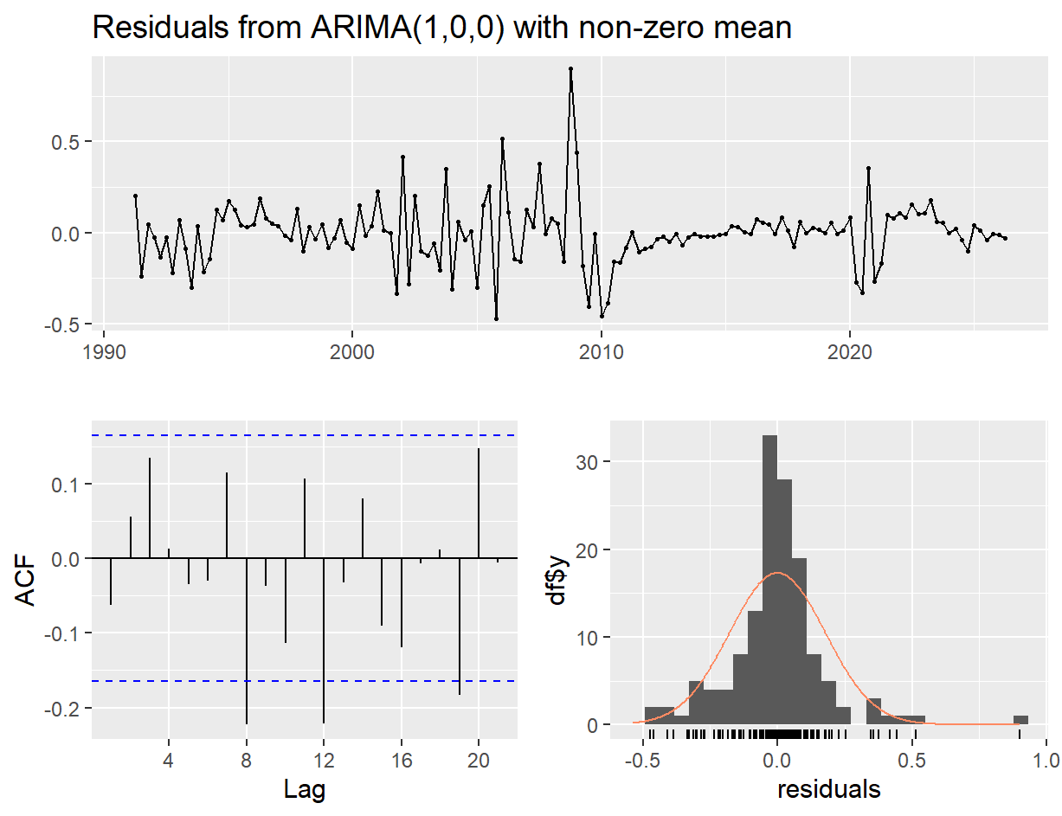
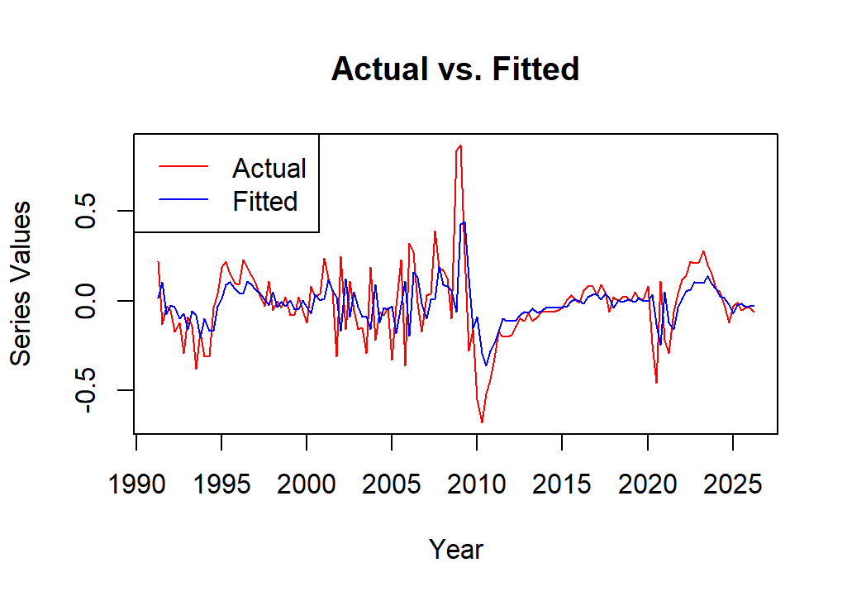
Paste Ljung-Box test results for the ARIMA residuals, produced on the left side screen in R, at the same time the residual diagnostics graphics is produced

Paste the ARIMA actual vs. fitted chart

Paste the Excel chart showing the actual series with the ARIMA forecast

Use this text box to state whether the final model’s residuals are white noise. Does the model capture the series autocorrelation?

STATEMENT ABOUT MODEL’S FINAL RESIDUALS
Use this text box to make observations about the forecast length, the choice of ARIMA parameters given what you see in the ACF and PACF charts, or any other aspect of the forecast you think is worth mentioning.

FORECAST OBSERVATIONS
Paste ARIMA residuals diagnostic chart, with the three small visuals

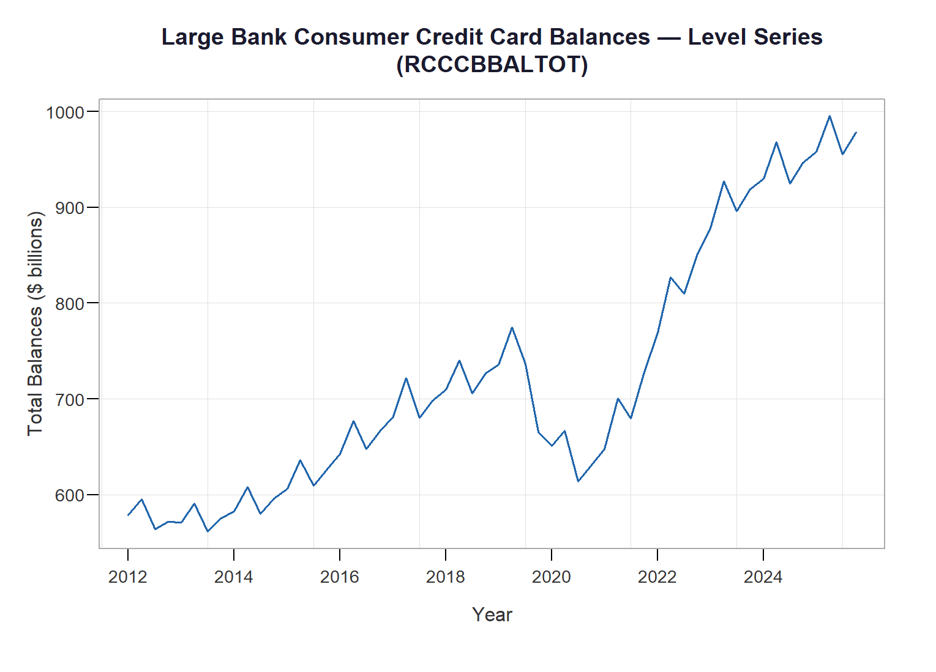
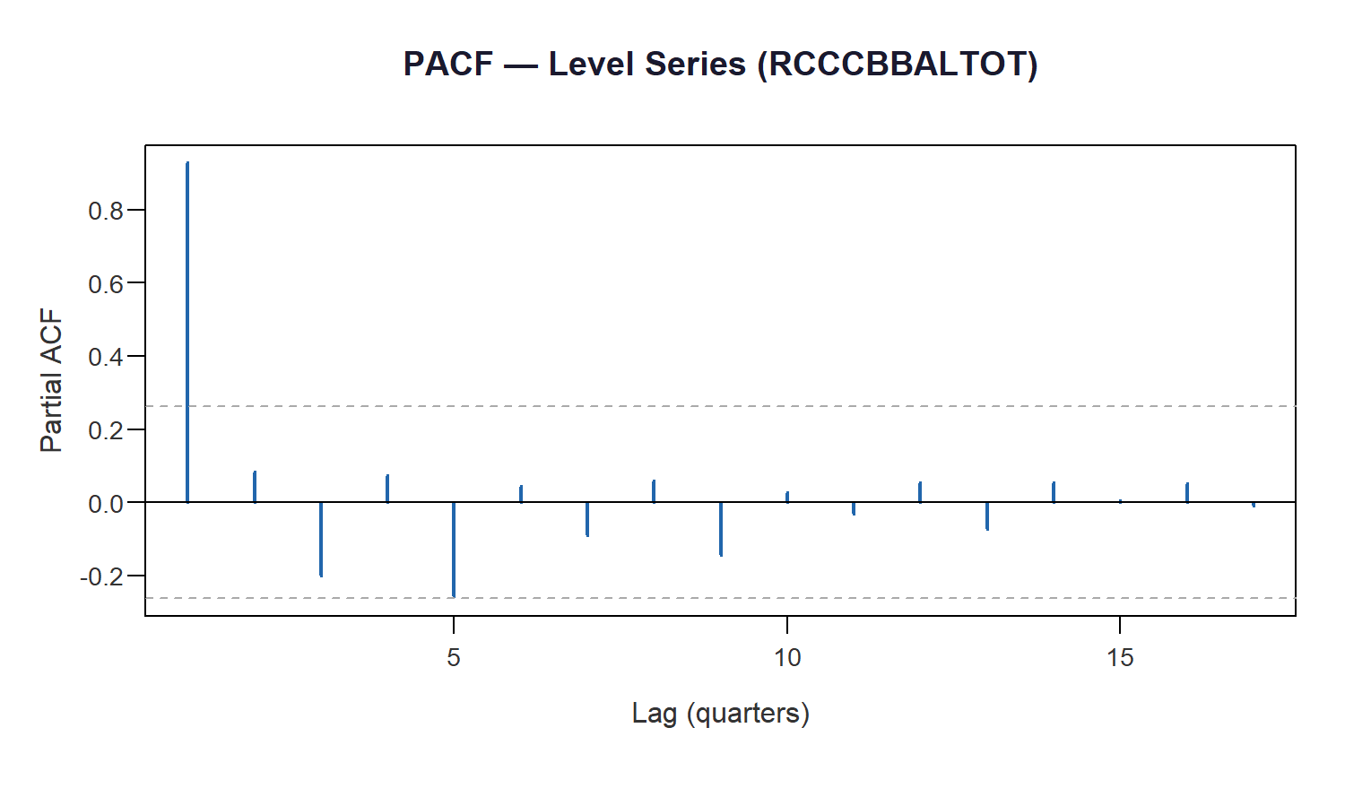
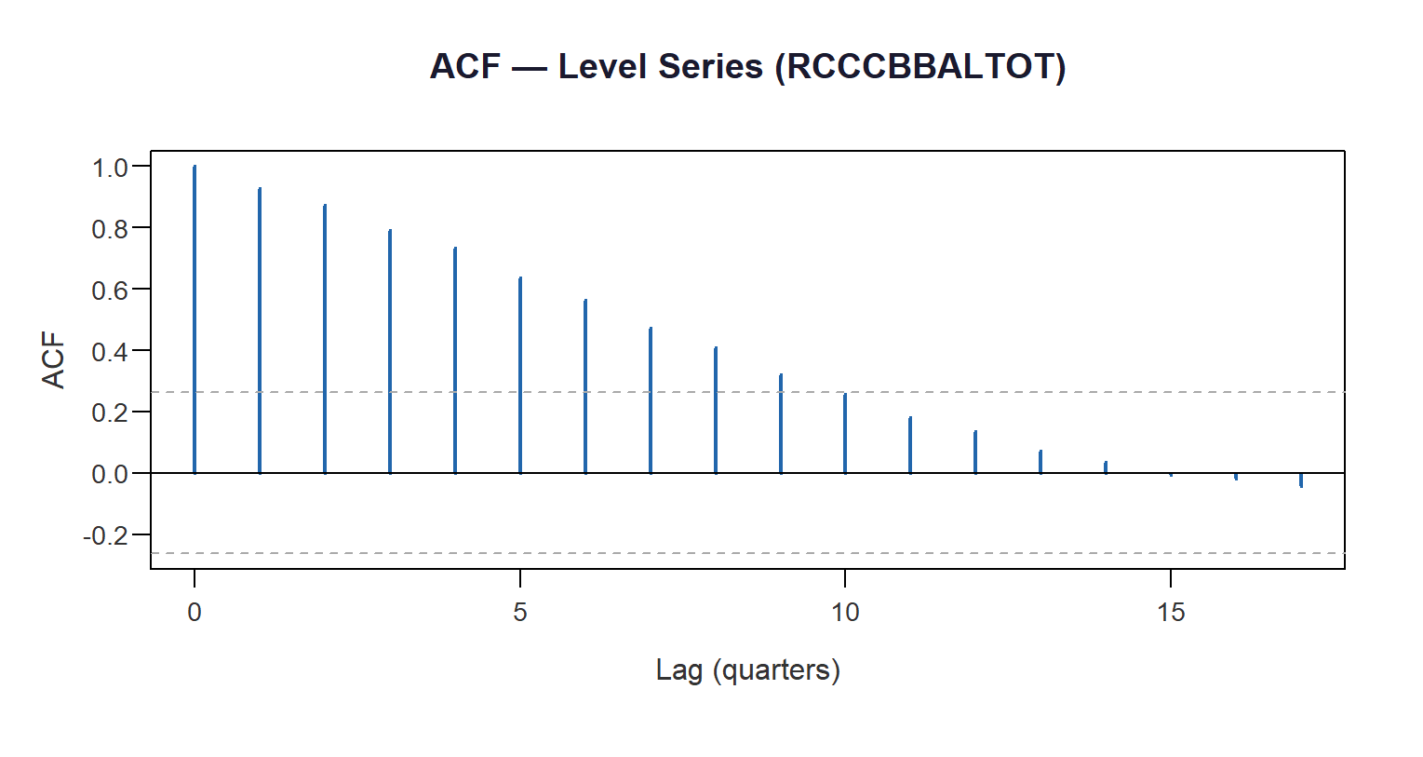
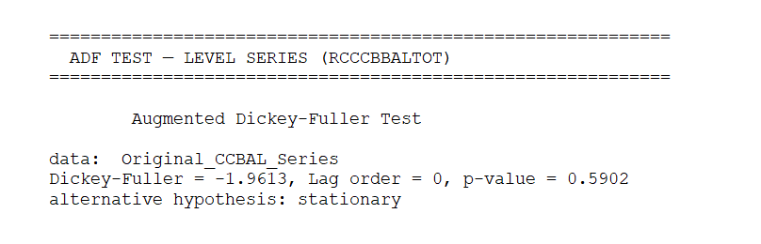
In this and the next box paste the ACF and PACF for the level series

Paste the ADF test results for the level series here

Paste the level series chart here

Use this box to describe important observations on the level series. As you get the series ready for modeling and forecasting, use this box to point out any relevant observations from the outputs on this page.

OTHER OBSERVATIONS

Use this box to describe the ACF and PACF outputs for the credit card delinquencies level series. Paste the ACF and PACF outputs in the two bottom boxes to the right.

CREDIT CARD
BALANCES
Use this text box to describe/discuss the time credit card delinquencies level series, what you observe, thoughts on driving patterns, etc. Use the large box to the right to paste the level series chart.

LEVEL SERIES PLOT
ADF TEST FOR LEVEL SERIES

Use this box to describe the results of the ADF test for the credit card delinquencies level series. Paste the image of the ADF test result in the smaller box to the right.

ACF AND PACF

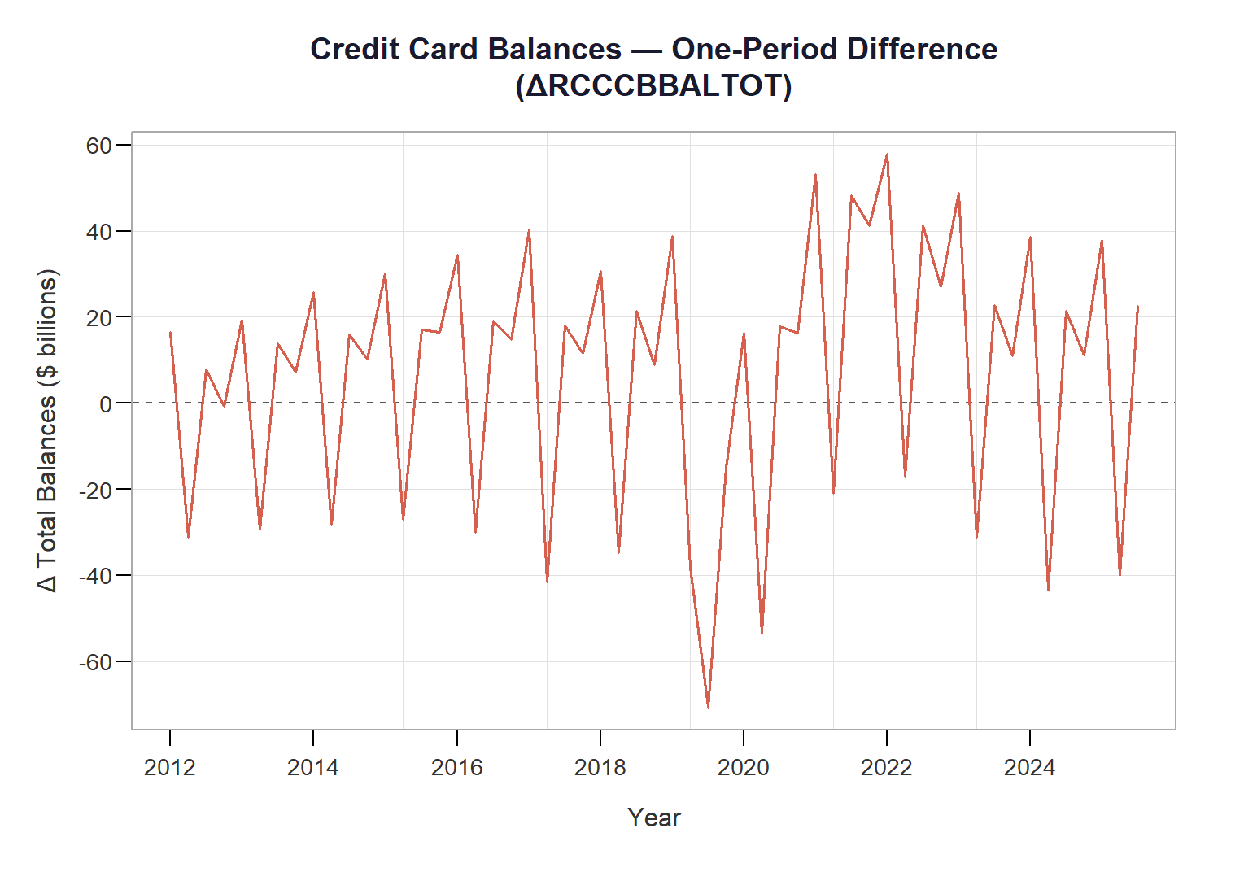
Paste the one-period difference series chart here

CREDIT CARD
BALANCES
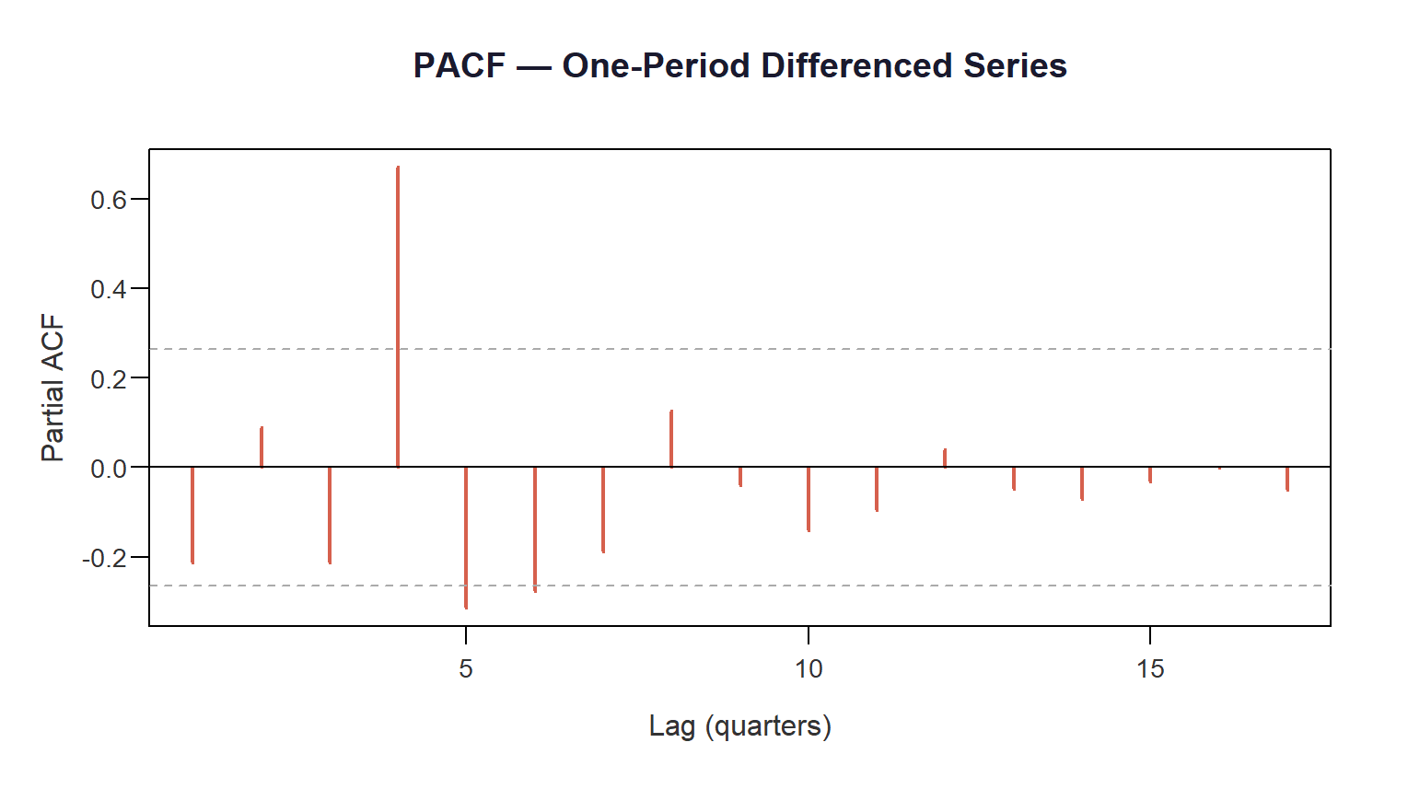
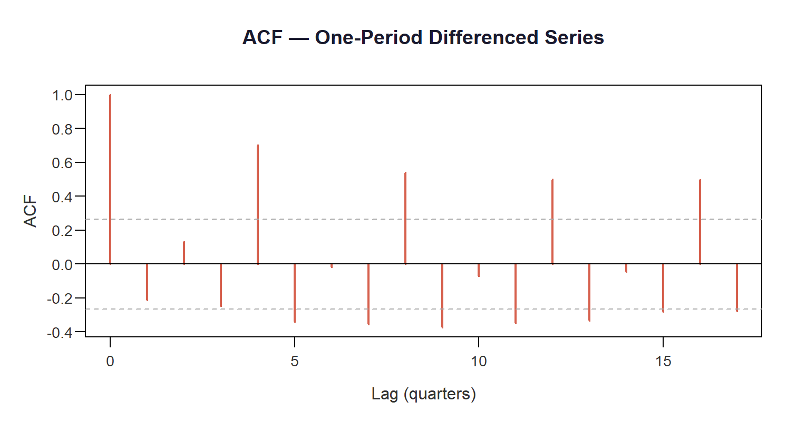
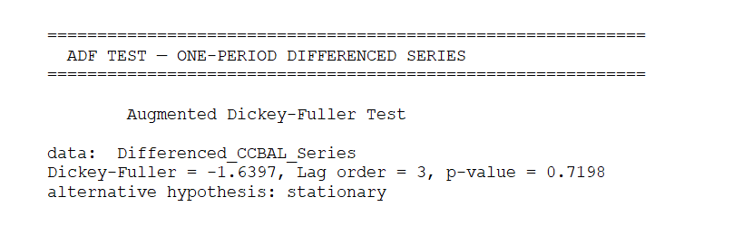
In this and the next box paste the ACF and PACF for the one-period difference series

Paste the ADF test results for the one-period difference series here

Use this box to describe important observations as a result of applying the one-period difference. As you get the series ready for modeling and forecasting, use this box to point out any relevant observations from the outputs on this page.

OTHER OBSERVATIONS

Use this box to describe the ACF and PACF outputs for the one-period difference credit card delinquencies series. Paste the ACF and PACF outputs in the two bottom boxes to the right.

ACF AND PACF FOR ONE_PERIOD DIFFERENCED SERIES

ADF TEST FOR ONE-PERIOD DIFFERENCED SERIES

Use this box to describe the results of the ADF test for the one-period difference credit card delinquencies series. Paste the image of the ADF test result in the smaller box to the right.

ONE-PERIOD DIFFERENCE SERIES PLOT
Use this text box to describe/discuss the one-period difference credit card balances series. Describe what you observed, thoughts on driving patterns, etc. Use the large box to the right to paste the level series chart.

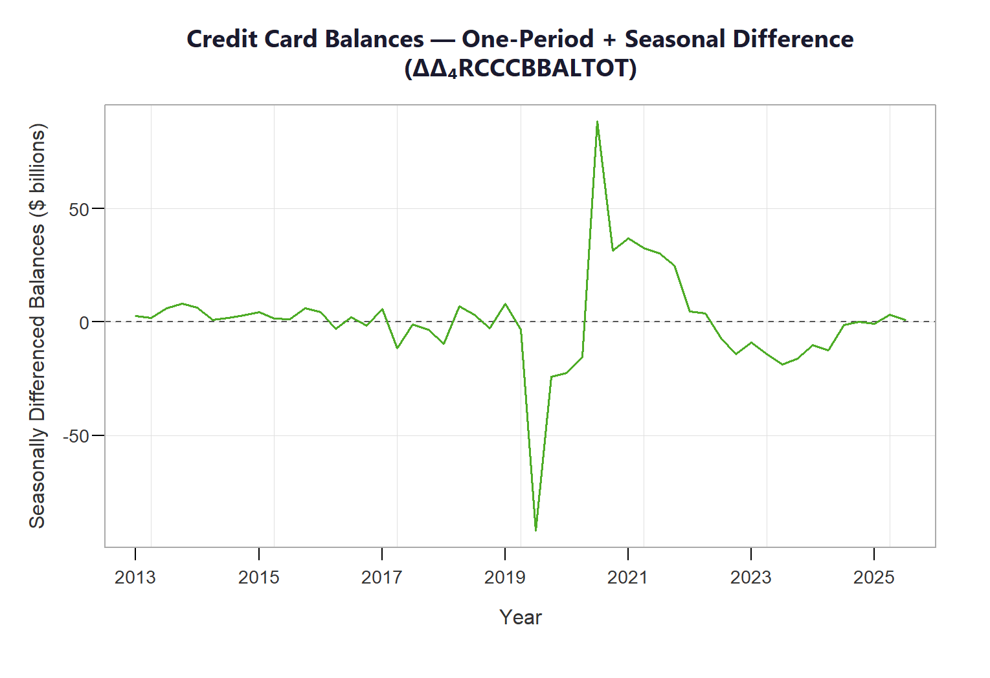
Paste the seasonally differenced series chart here

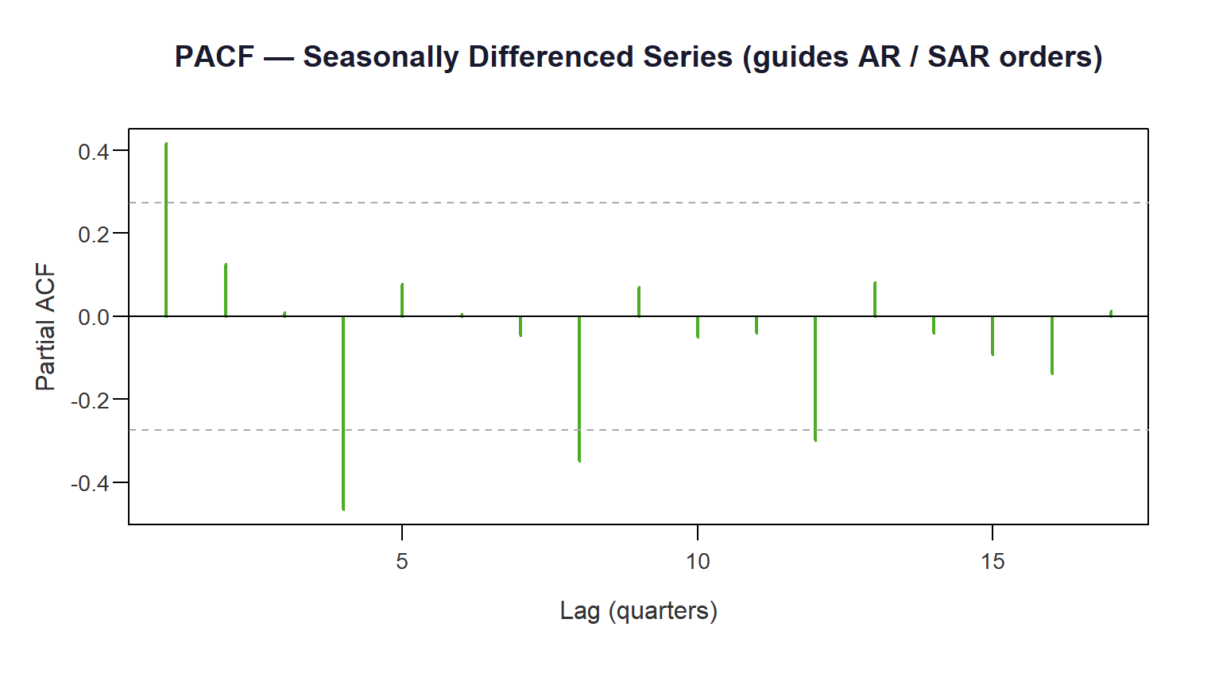
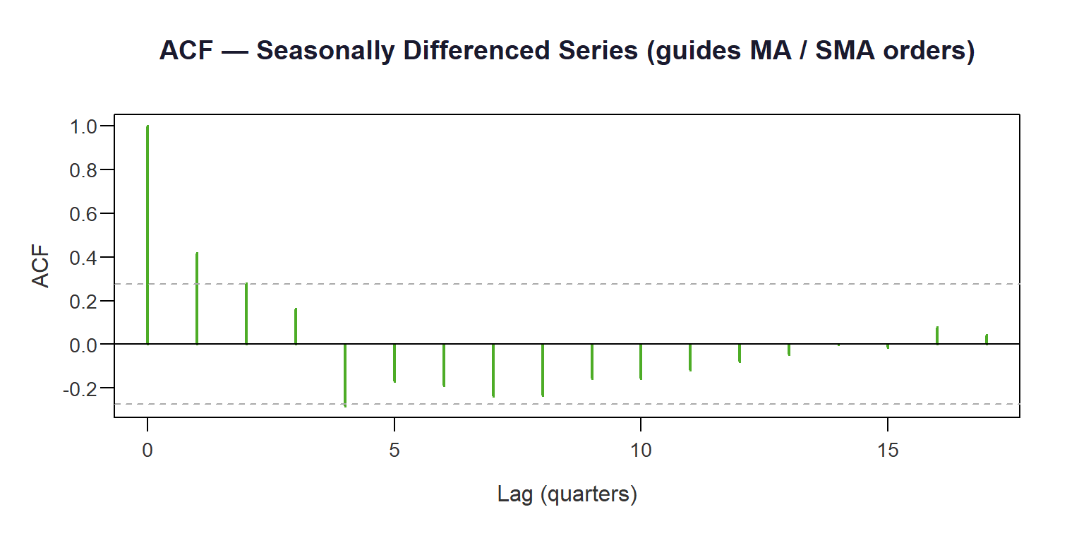
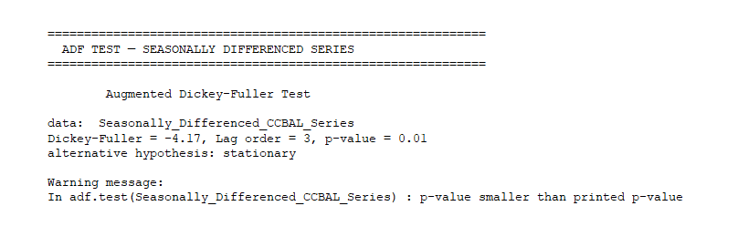
In this and the next box paste the ACF and PACF for the seasonally differenced series

Paste the ADF test results for the seasonally differenced series here

Use this box to describe important observations as a result of applying the seasonal difference. As you get the series ready for modeling and forecasting, use this box to point out any relevant observations from the outputs on this page.

OTHER OBSERVATIONS

Use this box to describe the ACF and PACF outputs for the seasonally differenced credit card delinquencies series. Paste the ACF and PACF outputs in the two bottom boxes to the right.

CREDIT CARD
BALANCES
ACF AND PACF FOR SEASONALLY DIFFERENCED SERIES

ADF TEST FOR SEASONALLY DIFFERENCED SERIES

Use this box to describe the results of the ADF test for the seasonally differenced credit card delinquencies series. Paste the image of the ADF test result in the smaller box to the right.

SEASONALLY DIFFERENCED SERIES PLOT
Use this text box to describe/discuss the seasonally differenced credit card balances series. Describe what you observed, thoughts on driving components, etc. Use the large box to the right to paste the level series chart.

CREDIT CARD BALANCES SERIES, SEASONAL ARIMA
FORECAST OUTPUT
Use this text box to describe the Seasonal ARIMA (SARIMA) forecast results, how you did it and what you observe.

In the first box below, to the left, paste the actual vs. fitted chart from R. In the box to the right, paste an Excel chart with a portion of the actual series, together with the SARIMA forecast. Then, in the next box to the left, paste the residual diagnostics, and in the last box, paste the Box-Ljung white noise test results. Follow the “How-To” video instructions.

CREDIT CARD BALANCES,
SEASONAL ARIMA FORECAST

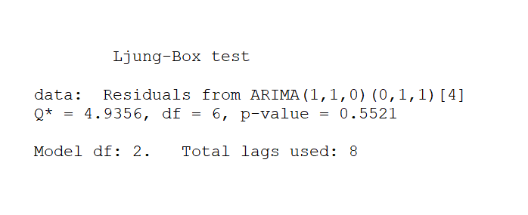
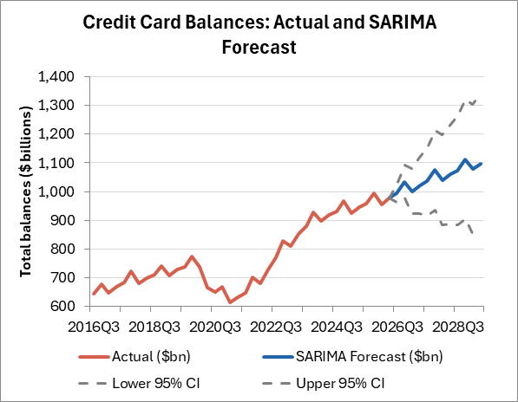
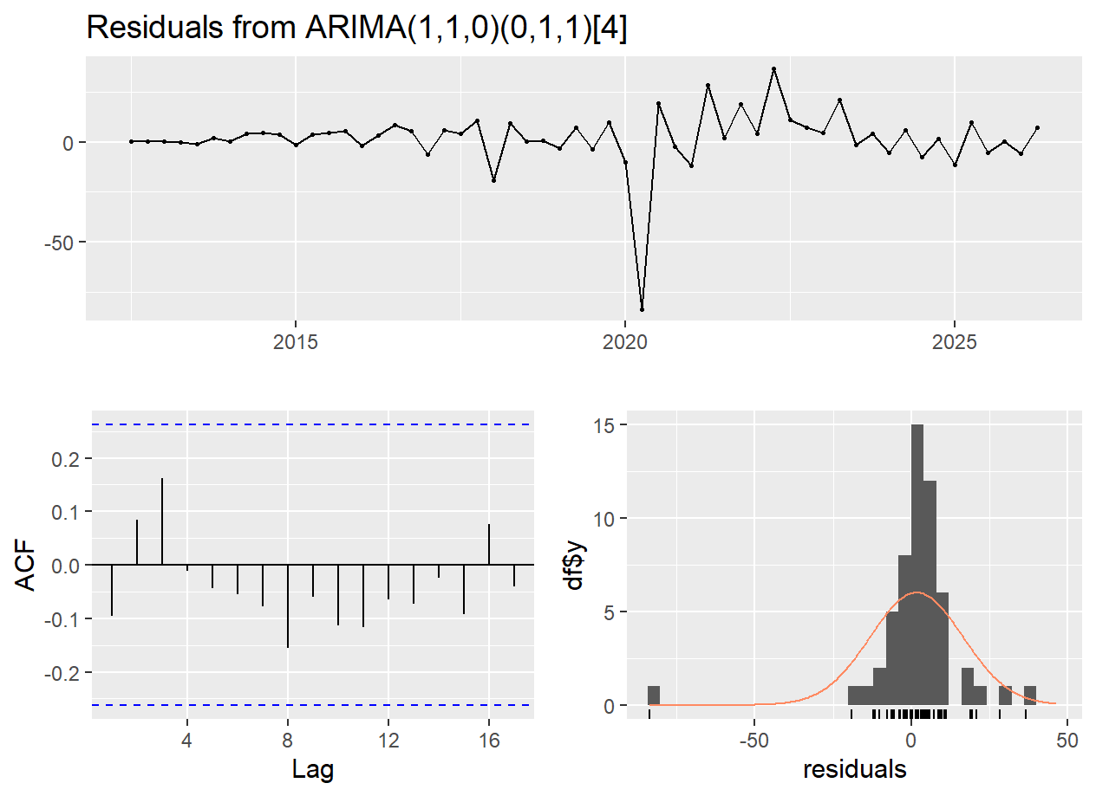
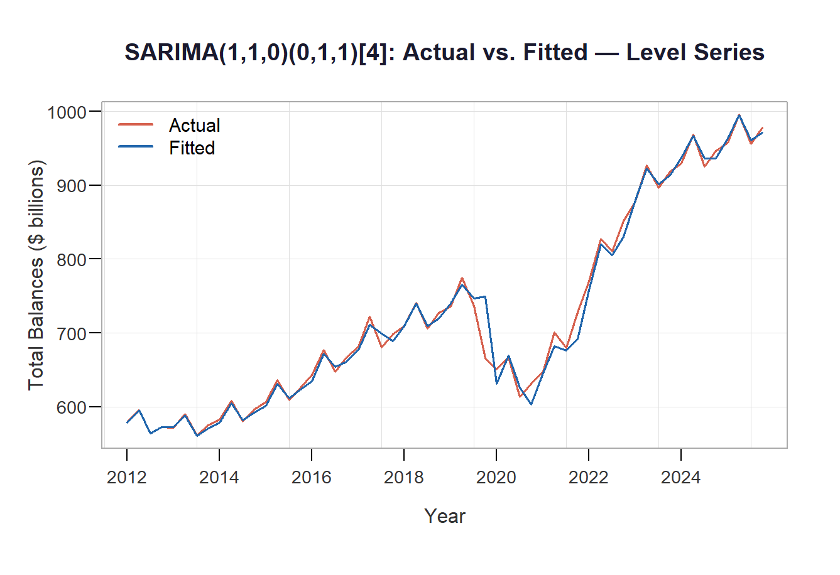
Use this text box to make observations about the forecast length, the choice of SARIMA parameters given what you see in the ACF and PACF charts, or any other aspect of the forecast you think is worth mentioning.

FORECAST OBSERVATIONS
Paste Ljung-Box test results for the SARIMA residuals, produced on the left side screen in R, at the same time the residual diagnostics graphics is produced

Paste the Excel chart showing the actual series with the SARIMA forecast

Paste SARIMA residuals diagnostic chart, with the three small visuals

Paste the SARIMA actual vs. fitted chart

STATEMENT ABOUT MODEL’S FINAL RESIDUALS
Use this text box to state whether the model’s residuals are white noise. Does the model capture the series autocorrelation?

After the presentation, the bank's CCO says, "We should use your delinquency forecast in our next 10Q report. But I'm worried about two things. It does not seem the forecast is consistent with the period of high interest rates, which historically correlates with higher delinquencies. Don’t you think the model is less pessimistic than it should be? Does that mean we should simply override your model's forecast with a more pessimistic number to account for the current interest rate environment? Or should we report the model output as-is and add a qualitative caveat?" How would you reply to the COO? Justify your answer.
Address both concerns directly. In your answer, explain what confidence intervals actually communicate to a non-technical reader, why overriding a model forecast with judgment requires a clear evidentiary basis, and how you would recommend presenting the results honestly without either overstating or understating the uncertainty.

Use this text box to answer the question or discuss the results as requested. Keep your discussion to no more than 300 words and do not exceed the text box space.

You are presenting your credit card balance forecast to the bank's retail lending committee. A senior risk officer interrupts you mid-presentation and says, "The credit card balance projections do not show any sudden change in direction, which suggests consumers are not changing their credit habits. Shouldn't we take that as a warning sign and tighten our underwriting standards now, before delinquencies spike? Are these results somewhat concerning? How confident are you really about this model? What lending strategy should we implement based on the results? How do you respond? Consider the modeling methodology and results to answer the risk officer’s questions and assertions.
Use this text box to answer the question or discuss the results as requested. Keep your discussion to no more than 250 words and do not exceed the text box space.

OUTPUTS AND INTERPRETATION

DISCUSSION
DATA
Use this text box to answer the question or discuss the results as requested. Keep your discussion to no more than 250 words and no exceeding the text box space.

You are explaining the details of your credit card balance SARIMA model to the bank's CFO, who has no modeling background but is known for sharp, practical thinking. The CFO raises two challenges: "Our loss mitigation team already projects balances and delinquencies to continue increasing. What does your seasonal model add that we're not already getting based on their knowledge of the market?" The CFO also said, "Plus, a model validator I spoke with flagged that SARIMA confidence intervals can be too wide. In fact, validators are skeptical about your model.” Respond to the CFO’s questions and statements, with an emphasis on whether the model produces reliable forecasts. Justify your answer.
A model validator reads your SARIMA model report and sends you a message: "I ran your model on a loan sample that includes the 2008–2009 financial crisis period. The forecast errors during that window do not seem very large. This is strange and it may suggest the is incorrectly fitted and may need to be redesigned in favor of a macro-factor model that incorporates variables like unemployment, GDP growth, and interest rates. What is your reaction to the validator’s assertions? Justify your answer.
Use this text box to answer the question or discuss the results as requested. Keep your discussion to no more than 350 words and no exceeding the text box space.

PREDICTABILITY AND APPLICATIONS

DISCUSSION
CONCLUSION

Use this text box to state what you think is the main conclusion, learning, or implication from your analysis. Assume you are presenting your findings to a group of colleagues. Summarize for them your main conclusion, i.e., what you think is the most important inference from the analysis. Keep your discussion to no more than 250 words and no exceeding the text box space.

